Project Development Phase
Model Performance Test

Date | 08 October 2026
Team ID | 9100Byte
Project Name | Implement Client Script & UI Policy (Incident)
Maximum Marks | 10 Marks

Model Performance Testing:
Project team shall fill the following information in model performance testing template.
S.No. | Parameter | Values | Screenshot
1. | Rule Execution / Validation Metrics | This project is not an ML model. Validation is based on functional execution: mandatory field enforcement, automatic Urgency update, save blocking and list-edit restriction. | 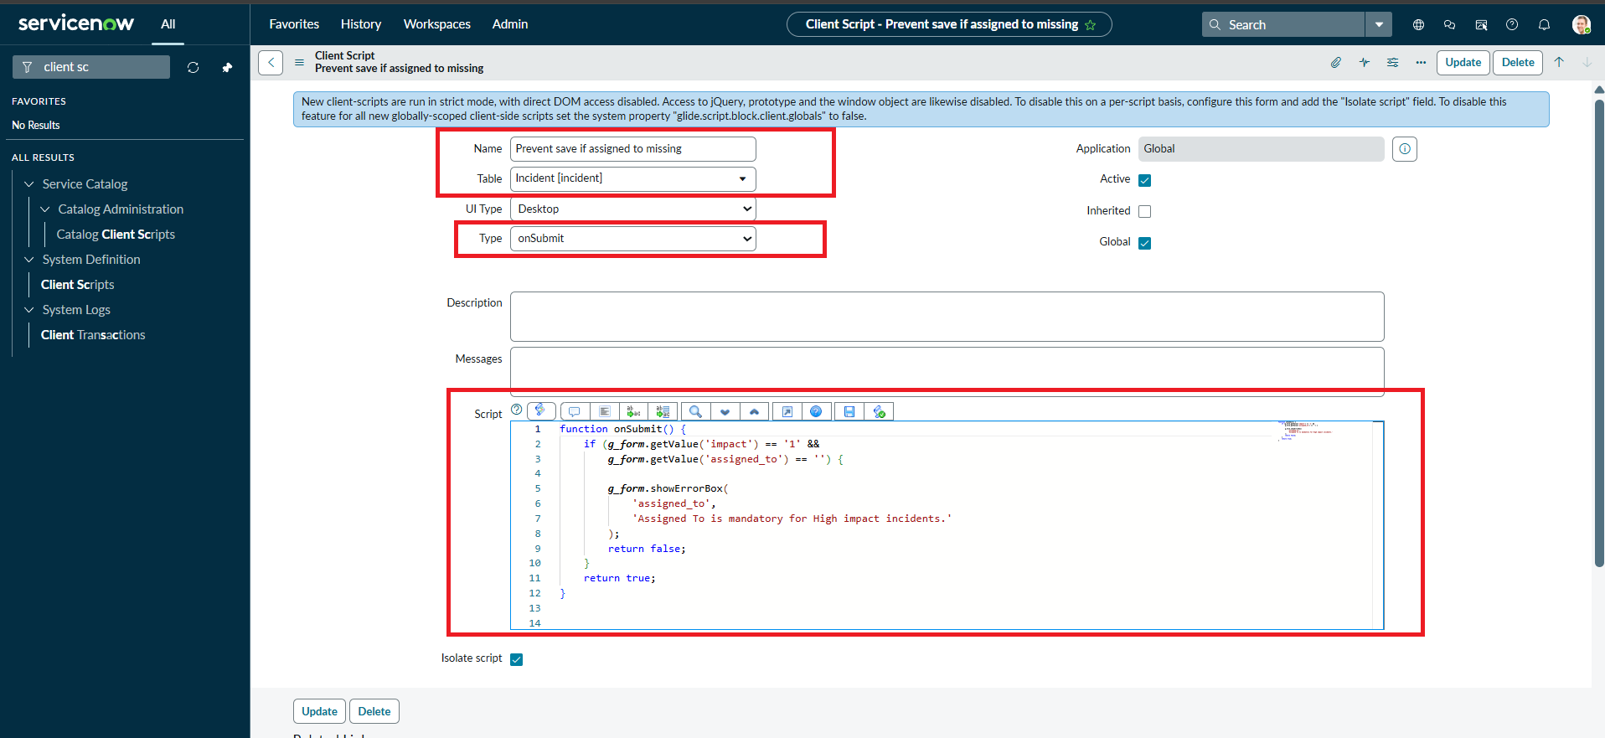
2. | Configuration Verification | Verify Impact = 1 – High; Assignment group mandatory; Urgency read-only; Reverse if false enabled; and Client Script types onChange, onSubmit and onCellEdit. | 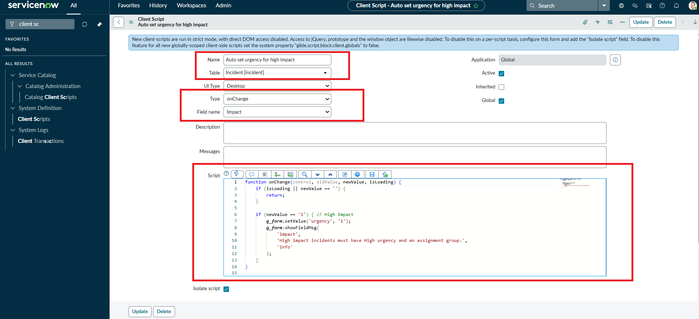

Execution Result Summary
Overall Result: PASS – implementation behavior is evidenced by the supplied ServiceNow screenshots and project document.
UAT Result: PASS – all listed functional scenarios are documented as successfully configured/verified.
Defects: None identified in the supplied evidence.
Evidence Status: Existing screenshots from the submitted implementation document have been retained and reused.
Project: Implement Client Script & UI Policy (Incident) | Team: 9100Byte | Date: 08 October 2026
Note: This project does not use a machine-learning model. The template is completed using the project’s actual rule execution and validation evidence rather than inventing ML metrics.
Implementation Evidence
Evidence: Supplied ServiceNow implementation screenshot(s).
image7.png
image6.png

